 | 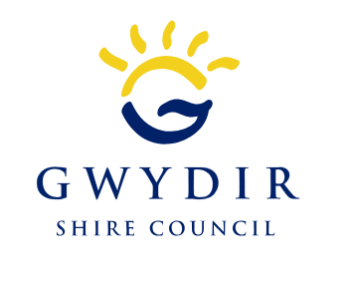
COUNCIL ASSESSMENT REPORT - Amended
NORTHERN REGIONAL PLANNING PANEL

PANEL REFERENCE & DA NUMBER | PPSNH-287- Gwydir DA 48/2023
PROPOSAL | To construct a new Public Administration Building complex on the land, including part-retention of the former memorial hall façade and demolition of the dwelling at 39 Cunningham Street. (Note: Demolition of the previous council facilities and adjoining commercial development is covered under PAN-409455)
ADDRESS | 33 to 35 Maitland Street Bingara being Lot 20, Section 38, DP758111, Lot 1 DP87721 and 39 Cunningham Street being Lot A DP 156384.  Access is through Lot A DP 156384
APPLICANT | Gwydir Shire Council
OWNER | Gwydir Shire Council
DA LODGEMENT DATE | 22 February 2024
APPLICATION TYPE (DA, Concept DA, CROWN DA, INTEGRATED, DESIGNATED) | DA
REGIONALLY SIGNIFICANT CRITERIA | Clause 3A and 3B, Schedule 6 of State Environmental Planning Policy (Planning Systems) 2021 :  Council is the applicant and owns the land, and the capital value is above $5,000,000.
CIV | $5,050,000 (excluding GST)
CLAUSE 4.6 REQUESTS | Nil
KEY SEPP/LEP | SEPP (Resilience and Hazards) 2021 – Chapter 4 Remediation of Land  State Environmental Planning Policy (Sustainable Buildings) 2022  Gwydir Local Environmental Management Plan 2013
TOTAL & UNIQUE SUBMISSIONS & KEY ISSUES IN SUBMISSIONS | A single submission was received from the owner of 39 Maitland Street (Lot 1 in DP 209422). This concerned the proposed use of the laneway to the rear of her lot which she indicated she understood that she owns, and has future plans to use.
DOCUMENTS SUBMITTED FOR CONSIDERATION | Attachment A – Draft Conditions of Consent  Attachment B – Amended SEE – 03 July 2023.  Attachment C – Plan Set for DA Approval. Contains the complete architectural plan set and landscaping plans.
SPECIAL INFRASTRUCTURE CONTRIBUTIONS (S7.24) | Nil
RECOMMENDATION | Approval with Conditions
DRAFT CONDITIONS TO APPLICANT | Yes
SCHEDULED MEETING DATE | 24 July 2024
PLAN VERSION | Issues C and D as per draft conditions list.
PREPARED BY | Angus Witherby
DATE OF REPORT | 16 July 2024

EXECUTIVE SUMMARY

This report responds to the submission of amended plans for the application, following previous feedback from the Panel. The key change is the purchase and proposed demolition of the dwelling on Lot A (39 Cunningham St) which was effectively surrounded by the initial development proposal. This lot is now proposed for carparking, and the report has been modified accordingly. Council has accepted the modification to the application. It also incorporates relevant material from the supplementary report to the original report.
The use consists of a combined public administration building complex as defined in Gwydir Local Environmental Plan 2013 (the LEP). The site is zoned RU5 Village and both of the uses are permitted with consent in this zone.
The development site comprises the following land parcels:
Lot Descriptor | Area | Current Use / Future Use
Lot 1 in DP 87721 | 915m² | Old buildings vacated due to rising damp problems, now demolished. Part of new building to be located here.
Lot 20 Section 38 DP 758111 | 2,034m² | Old buildings vacated due to rising damp problems, now demolished. Part of new building to be located here, also new car parking and traffic circulation.
Lot A in DP156384 | 852m² | Former dwelling, now proposed to be demolished, to be used for carparking as part of revised site layout. This lot was not included in the original application.
The proposed development comprises:
- Previous demolition of the existing Council buildings and adjoining commercial building and ancillary infrastructure at 33-35 Maitland Street (subject to Development Consent DA24/2023 - PAN-409455), excluding the façade of the Soldiers Memorial Building which is to be retained)
- Minor demolition of buildings on the site of the previous Council facilities and the demolition of No. 39 Cunningham Street

- Community facility (~ 338m² GFA) comprising:
- Community forecourt and greenspace;
- Visitor information centre;
- Public amenities;
- Community/councillors meeting room;
- Customer Service Centres;
- Mayor’s office and
- Council Chambers.
- Office premises (~ 766m² GFA) comprising:
- Centrelink office and quiet space;
- Staff recreation and collaborative areas;
- Offices and meeting rooms,
- IT Hub;
- Gwydir News Office; and
- Breakout area.

- Landscaping;

- Twenty-six (26) carparking spaces which are being provided on the site of the former dwelling, together with two extra spaces which are being provided through formalization of angle parking in Maitland Street;

- Delivery and services area; and

- Vehicular access from Cunningham Street.
Key issues: to respect the streetscape character with the new design, and to retain indicative elements of the previous building frontage (not heritage listed but significant nonetheless); and to ensure that adequate parking and access is available without conflict with residential development or the Council depot, adjoining.

Community concern: The owner of Lot 1 in DP 209422 raised concern with the proposed use of the land at the eastern end of that lot as part of the access for the new development. This ROW is now not to be used, as part of project redesign.

Public Interest: The proposed facility will provide valuable infrastructure to enable enhanced service provision to the local community. No significant negative impacts have been identified, and it is considered that on balance the public interest will be well served by this development.

Recommendation: That the application be approved with conditions.

Section 4.15(1) Matters
One issue identified during the s4.15(1) review was that the site has contamination. This is presently undergoing remediation and provision of a site clearance certificate has been included as a draft condition to be satisfied prior to issue of construction certificate. Further details are provided later in this report against the review of SEPP requirements.

- THE SITE AND LOCALITY

  - The Site
The site is located within the Bingara Town Centre as shown on the figure below.
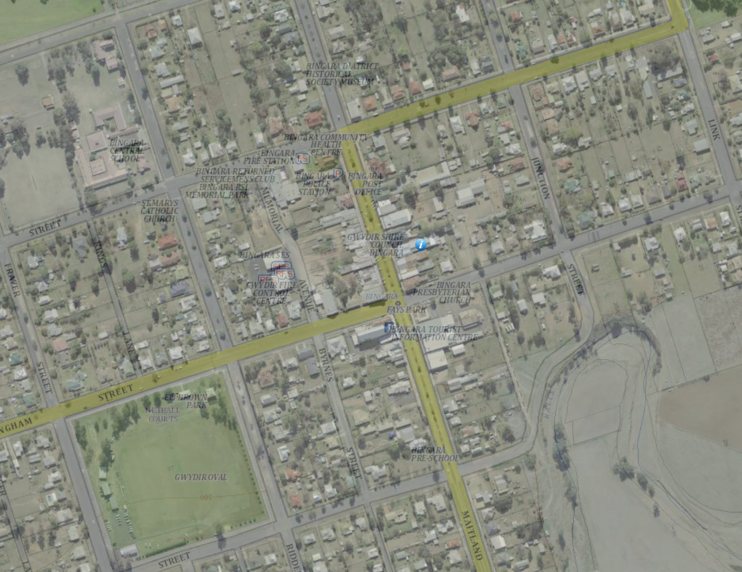
Figure: Site location in context
The site previously contained two main buildings – a soldiers’ memorial hall and a Council administration building. Both of those buildings (and ancillary sheds on the site) and have now been demolished pursuant to DA24/2023 (PAN-409455). The redevelopment site is shown on the Figure below:
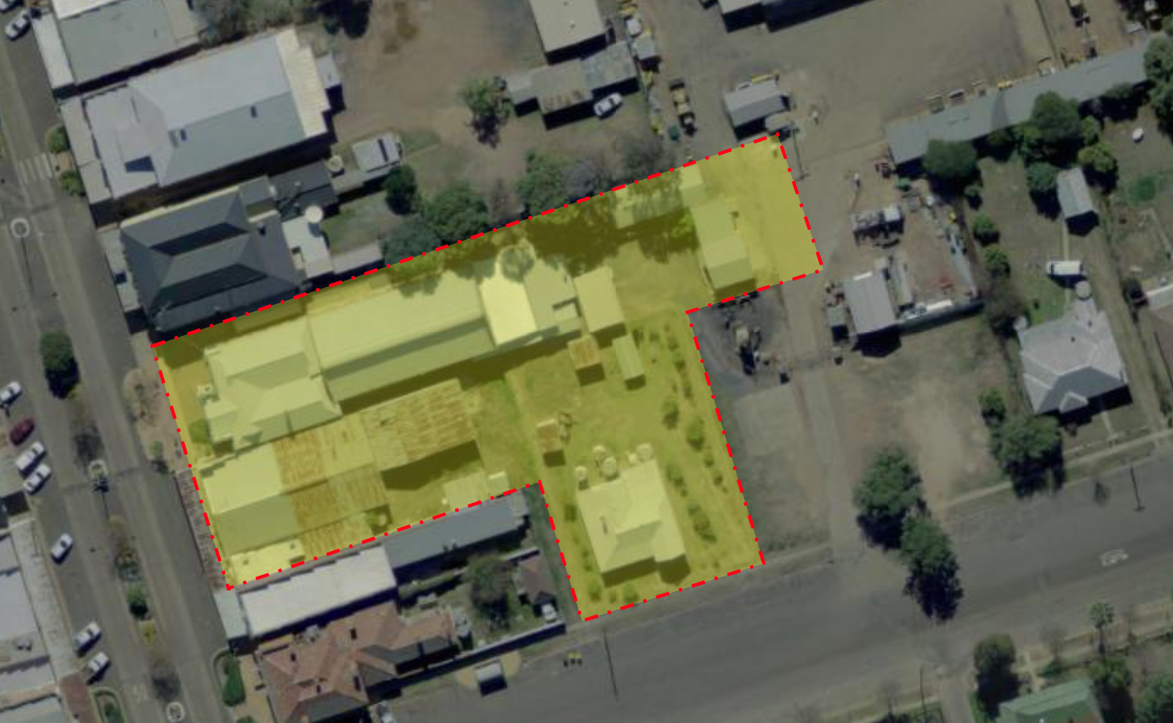
Figure: Aerial View

The site has a total development area of 3901m2. The land is flat, and located within the Bingara town centre. The site has been substantially developed in the past, but includes limited trees along the northern boundary.

The site is not of heritage significance, although the DA for demolition of the previous Council buildings and adjoining commercial building was conditioned to retain the bulk of the façade of the former memorial hall, as this was of value to the local community. The façade is to be incorporated into the new development and a condition is recommended to ensure its protection during development (draft Condition 25)

The main development site has direct frontage to Maitland Street, which is a state significant road, with vehicular access being historically from the rear. All vehicular access is proposed to be from Cunningham Street.

The streetscape is typical of many small rural communities in NSW.

  - The Locality
The site is adjoined by commercial development to the north, an hotel, to the south by an existing commercial building, and by residential development to the west. The area is generally one and two storey development typical of a country town centre.

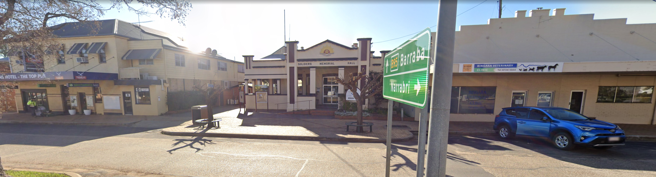
Figure: Streetscape prior to demolition of the Memorial Hall and the commercial building to the right

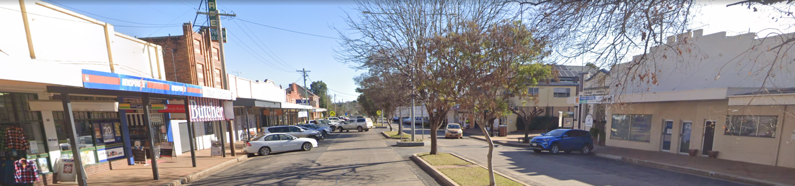
Figure: General streetscape view

Bingara does not have public transport, however the site is very well located with respect to existing services.

- THE PROPOSAL AND BACKGROUND

  - The Proposal
The proposal is for the re-build of the former uses on the site.
Demolition of the council buildings and adjacent commercial building has already occurred under a previous development application. There is a need to complete site demolition, remediation and decontamination prior to new construction occurring. Required demolition includes the recently purchased dwelling on Cunningham Street. Existing trees are to be retained. Consolidation of lots is recommended. Only incidental earthworks are anticipated, largely associated with new footings.

The proposed new development is shown below:
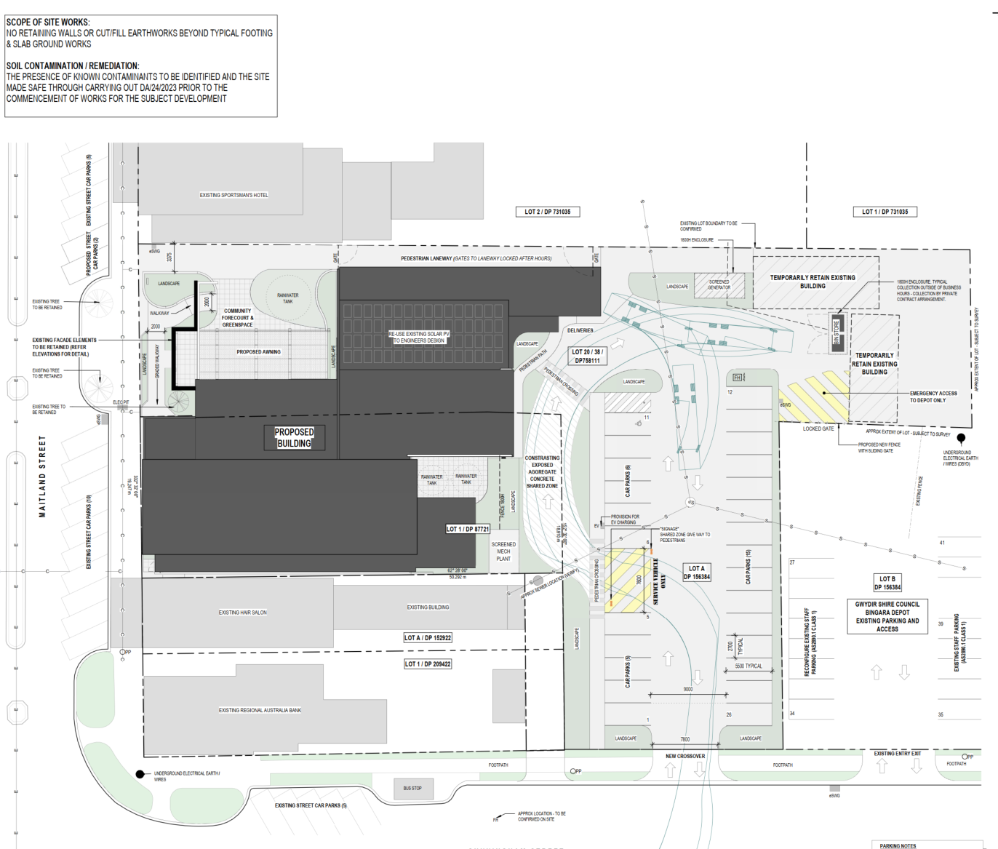
Figure: Proposed development
The proposed development will be a major feature of the streetscape, and a perspective view is shown below:
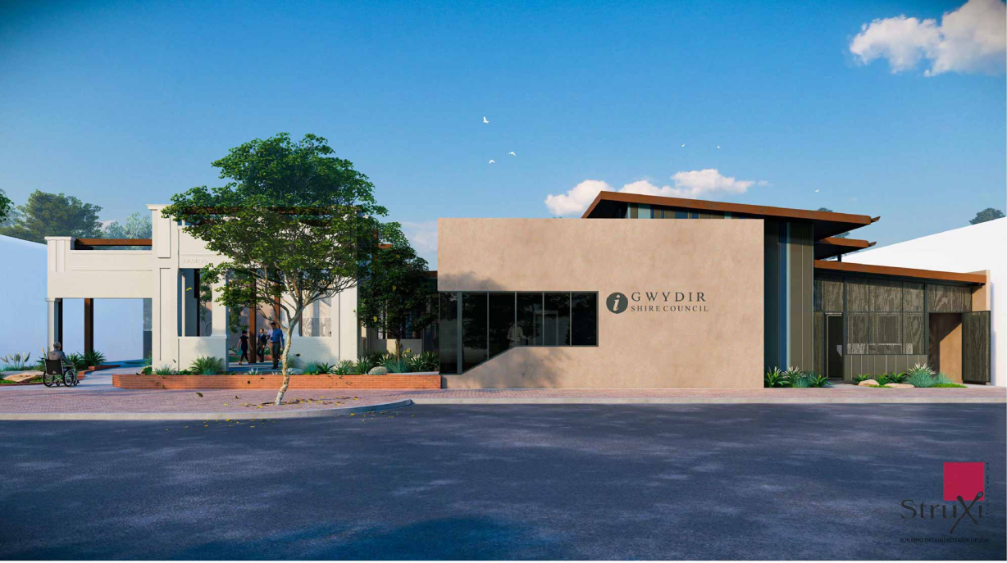
Figure: Street View
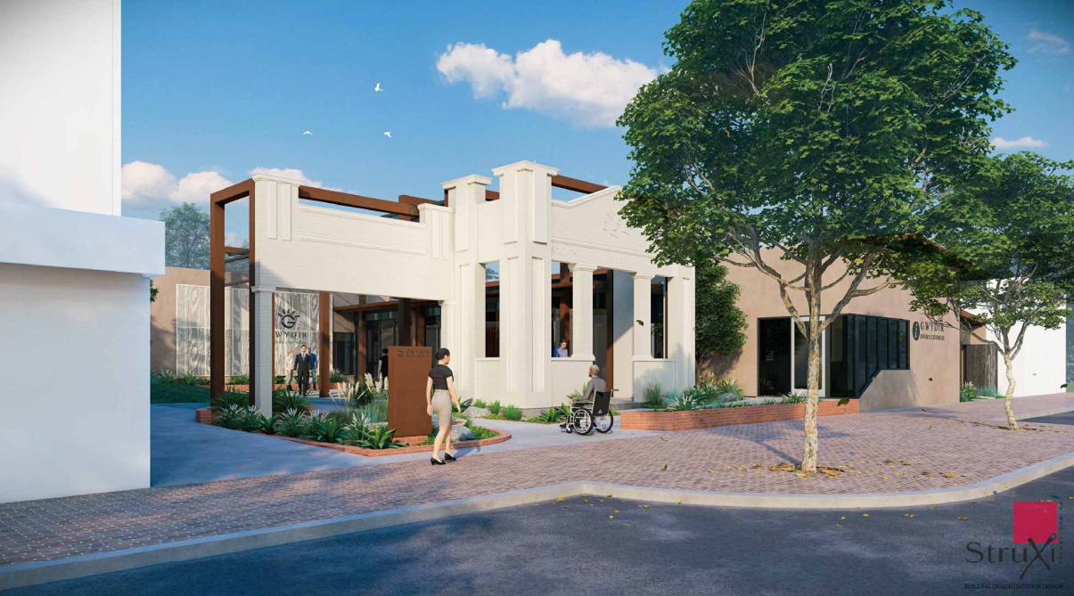Figure: Street View

The provision of public space is a key aspect of the development. This is shown in the following view:

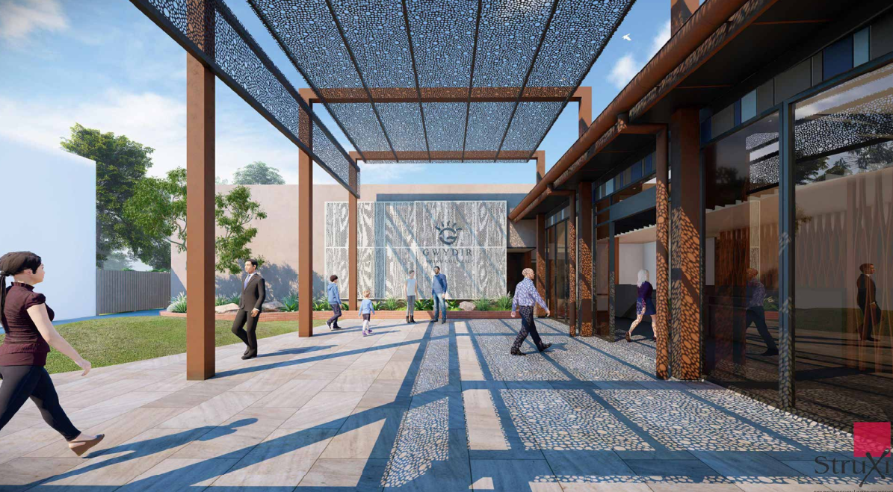
Figure: Public space area

Table 1: Development Data
Control | Proposal
Site area | 3550 m2 – No specific requirement
GFA | 1307m2 – No specific requirement
FSR (retail/residential) | N/A
Clause 4.6 Requests | Nil
No of apartments | N/A
Max Height | 6.45m (retained façade height) – No specific requirement.
Landscaped area | 195m2 (not including paved courtyard areas) – No specific requirement.
Car Parking spaces | 22 – determined on merit – No DCP applies
Setbacks | Variable – see site plans. Zero front setback is common in the town centre.

  - Background

The need for the development arose out of a series of problems with the existing buildings. This included rising damp, which, when the age and poor functionality of the existing building was considered, was both uneconomic and problematic to repair. Expert reports were obtained, and a decision was made to demolish the existing structures. This was the subject of a separate Development Application. A minor modification to this was required to align with the final design plans, and this is anticipated to be determined by way of approval prior to this DA being considered by the Panel.

The main issues arising are:

- Streetscape – Part retention of the memorial hall façade was considered essential in any site redevelopment. This has been achieved.
- Improved public and Council facilities – The provision of modern facilities will provide a community benefit as well as improved Council staff conditions.
- Provision of suitable parking and access.
The development application was submitted on 9 December 2023 following which a review was conducted. Further information was provided and it was then formally accepted for lodgement on 22 February 2024. A chronology of the development application since lodgement is outlined below including the Panel’s involvement (briefings, deferrals etc) with the application:

Table 2: Chronology of the DA
Date | Event
9 November 2023 | Pre DA Lodgement in Portal
28 November 2023 | Request for Information from Council to applicant (this was prior to Lodgement)
31 January 2024 | Amended plans lodged to address minor issues arising initial pre DA review dated 31 January 2024 accepted by Council under Cl 38(1) of the Environmental Planning and Assessment Regulation 2021 (‘2021 EP&A Regulation’) on Select Date.
5 February 2024 | Receipt of additional information from pre-lodge review.
22 February 2024 | DA lodged by Council
11 March 2024 | Application was placed on Council’s website and Facebook page, hard copies were available at the Bingara administration office, Bingara Library, Warialda Visitor Information Centre, Warialda administration office, a notice was placed on the site, and it was advertised in the Northern Daily Leader and neighbours were notified in writing. Neighbour notification consisted of notification of main street businesses/residences as well as the area surrounding the site (17 properties).
10 April 2024 | End of notification period.
Select Date | No referrals to external agencies
21 May 2024 | Panel considers the Council report and supplementary report and defers the matter pending resolution of issues, primarily around access.

  - Site History

The site has been the subject of a previous development application for demolition of the council buildings and adjoining commercial development. A concurrent modification to the demolition consent has now been determined. The façade of the memorial hall is the most significant aspect of public interest. No approvals or applications are affecting immediately adjoining sites.

- STATUTORY CONSIDERATIONS

When determining a development application, the consent authority must take into consideration the matters outlined in Section 4.15(1) of the Environmental Planning and Assessment Act 1979 (‘EP&A Act’). These matters as are of relevance to the development application include the following:

- the provisions of any environmental planning instrument, proposed instrument, development control plan, planning agreement and the regulations
(i) any environmental planning instrument, and
(ii) any proposed instrument that is or has been the subject of public consultation under this Act and that has been notified to the consent authority (unless the Planning Secretary has notified the consent authority that the making of the proposed instrument has been deferred indefinitely or has not been approved), and
(iii) any development control plan, and
(iiia) any planning agreement that has been entered into under section 7.4, or any draft planning agreement that a developer has offered to enter into under section 7.4, and
(iv) the regulations (to the extent that they prescribe matters for the purposes of this paragraph),
that apply to the land to which the development application relates,
- the likely impacts of that development, including environmental impacts on both the natural and built environments, and social and economic impacts in the locality,
- the suitability of the site for the development,
- any submissions made in accordance with this Act or the regulations,
- the public interest.

These matters are further considered below.

It is noted that the proposal is not considered to be:

- Integrated Development (s4.46)
- Designated Development (s4.10)
- Requiring concurrence/referral (s4.13)
- Crown DA (s4.33) - written agreement from the Crown to the proposed conditions of consent must be provided

  - Environmental Planning Instruments, proposed instrument, development control plan, planning agreement and the regulations

The relevant environmental planning instruments, proposed instruments, development control plans, planning agreements and the matters for consideration under the Regulation are considered below.

- Section 4.15(1)(a)(i) - Provisions of Environmental Planning Instruments

The following Environmental Planning Instruments are considered specifically relevant to this application:

- State Environmental Planning Policy (Biodiversity & Conservation) 2021
- State Environmental Planning Policy (Sustainable Buildings) 2022
- State Environmental Planning Policy (Resilience and Hazards) 2021

A summary of the key matters for consideration arising from these State Environmental Planning Policies are outlined in Table 3 and then considered in more detail following.

Table 3: Summary of Applicable Environmental Planning Instruments
(put Preconditions in bold)
EPI | Summary of Issues  (Brief summary) | Comply (Y/N)
State Environmental Planning Policy (Biodiversity & Conservation) 2021 | No matters arising. The land does not contain any native vegetation that is affected by the proposal | Y (see section of the report below)
State Environmental Planning Policy (Sustainable Buildings) 2022 | Compliance with requirements | Y (see section of the report below)
State Environmental Planning Policy (Housing) 2021 | No matters arising | N/A
State Environmental Planning Policy (Industry and Employment) 2021 | No matters arising | N/A
SEPP 65 | No matters arising | N/A
State Environmental Planning Policy (Planning Systems) 2021 | Chapter 2: State and Regional Development  Section 2.19(1) declares the proposal regionally significant development pursuant to Clause 3A and 3B of Schedule 6 as it comprises Council proposed development with a capital value of more than $5 million. | Y
State Environmental Planning Policy (Precincts—Central River City) 2021 or  State Environmental Planning Policy (Precincts—Eastern Harbour City) 2021 or  State Environmental Planning Policy (Precincts—Regional) 2021 or State Environmental Planning Policy (Precincts—Western Parkland City) 2021 | No matters arising | N/A
State Environmental Planning Policy (Primary Production) 2021 | No matters arising | N/A
SEPP (Resilience & Hazards) | Chapter 4: Remediation of Land. | Y (see section of the report below)
State Environmental Planning Policy (Resources and Energy) 2021 | No matters arising | N/A
State Environmental Planning Policy (Transport and Infrastructure) 2021 | No matters arising | N/A
Proposed Instruments | No proposed instruments apply. | N/A
LEP | - Clause 2.3 – Permissibility and zone objectives  - Clause 6.4(e) – Essential Services. | Y
DCP | No DCP applies – Generally Consistent with Bingara town plan | Y

SEPP (Biodiversity & Conservation) 2021

Consideration was given to Section 4.8(2) of the SEPP. No Koala plan applies to the land. Accordingly, this clause does not apply to the application.

SEPP (Sustainable Buildings) 2022

Clause 3.2(2) of State Environmental Planning Policy (Sustainable Buildings) 2022 requires that “Development consent must not be granted to non-residential development unless the consent authority is satisfied the embodied emissions attributable to the development have been quantified.”

The consent authority is the Regional Planning Panel. On this basis it is the Panel that needs to be satisfied that the requirements of the SEPP have been met. The Guidelines referred to in the SEPP have not yet been made available. We refer to the Embodied Emissions Technical Note (DPE undated) accessed 17 May 2024. Accordingly, the table provided below is sufficient.
Design Statement from the Architect
The proposed Bingara Administration Building responds to the State Environmental Planning Policy (Sustainable Buildings) 2022 Clause 3.2 as follows:

- the minimisation of waste from associated demolition and construction, including by the choice and reuse of building materials,
- Many of the materials from the existing building are unsuitable for re-use due to age and deterioration.
  - Bricks are soft – some have been salvaged for reuse as decorative finishes to the new tilt panel walls.
  - Timber was found to be brittle and unable to be salvaged. Roof framing material has been salvaged for re-use as joinery items within the new structure.
  - Existing solar panels are being re-used on the new building.
- a reduction in peak demand for electricity, including through the use of energy efficient technology,
- Solar Panels are being re-installed and augmented to the new building;
- All lighting and fixtures are LED
- HVAC is zoned into small zones and fitted with activity sensors to minimise un-necessary use
- a reduction in the reliance on artificial lighting and mechanical heating and cooling through passive design,
- All faces of the building have access to daylight. Staff areas and open office areas are deliberately exposed to natural light. Even the edge to the common wall incorporates high-level glazing designed to illuminate the internal space during daylight hours.
- Shading studies have been used to inform the placement of glazing, overhangs and other shading devices.
- the generation and storage of renewable energy,
- As above solar panels are being salvaged from the existing building for re-use.
- Battery storage was not considered necessary as the peak use time and peak generation time overlap meaning there is little efficiency to be gained from battery storage.
- the metering and monitoring of energy consumption,
- NCC 2022 Section J has been adopted in full in the design of energy systems.
- Separate monitoring of energy usage is available in the switchboard.
- the minimisation of the consumption of potable water.
- Roof water capture has been utilised on site for both on-site re-use and detention capacity to mitigate peak flows during rain events. Approximately 50,000 litters of stored water is available for use in sanitary facilities and on site irrigation and cleaning.

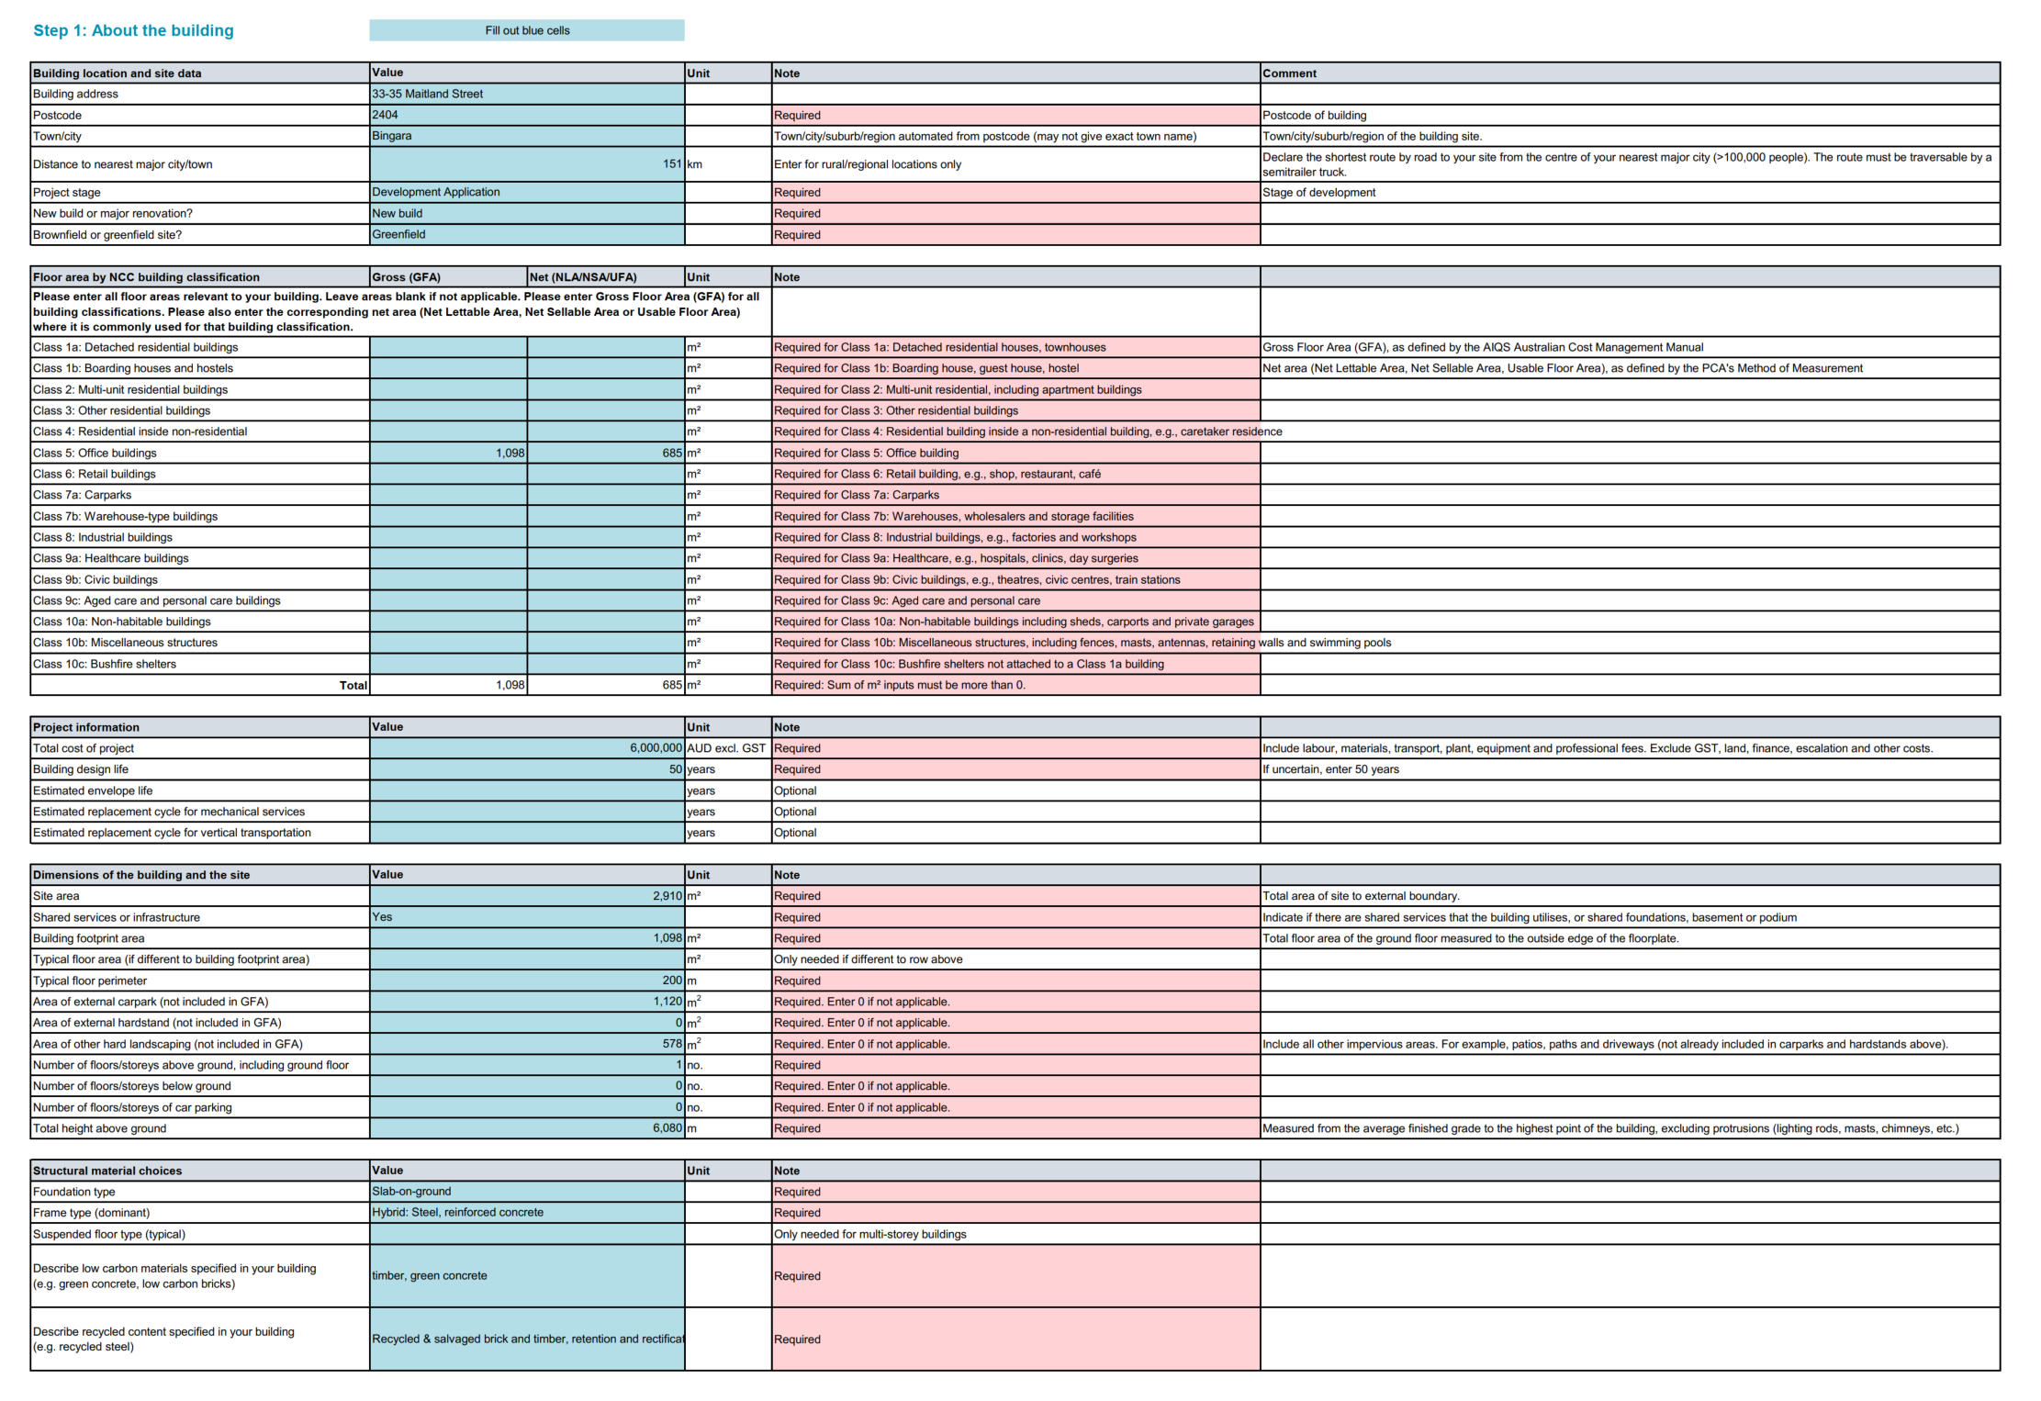
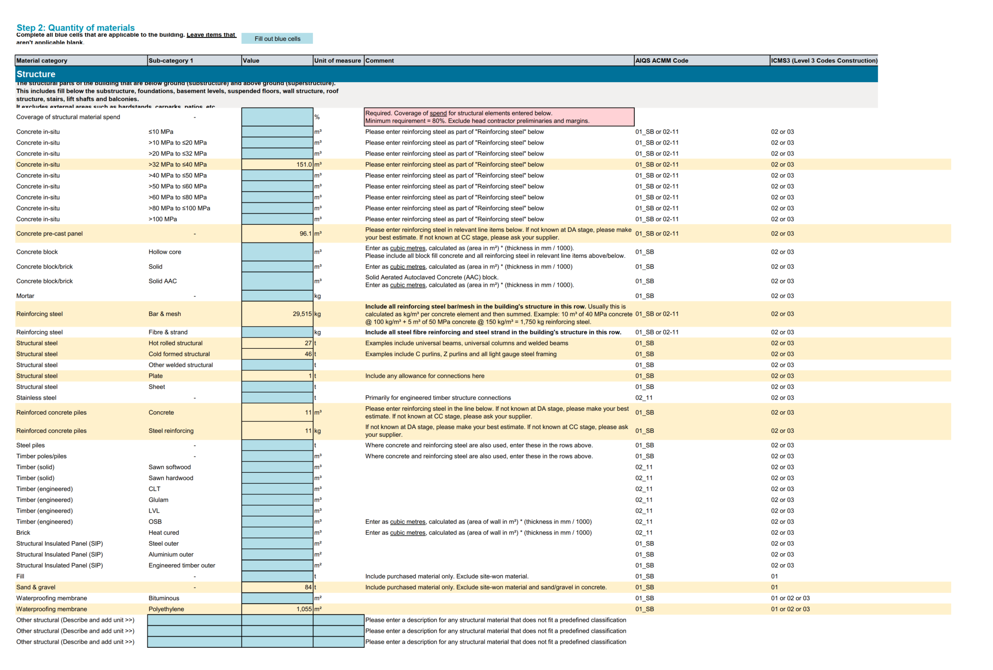
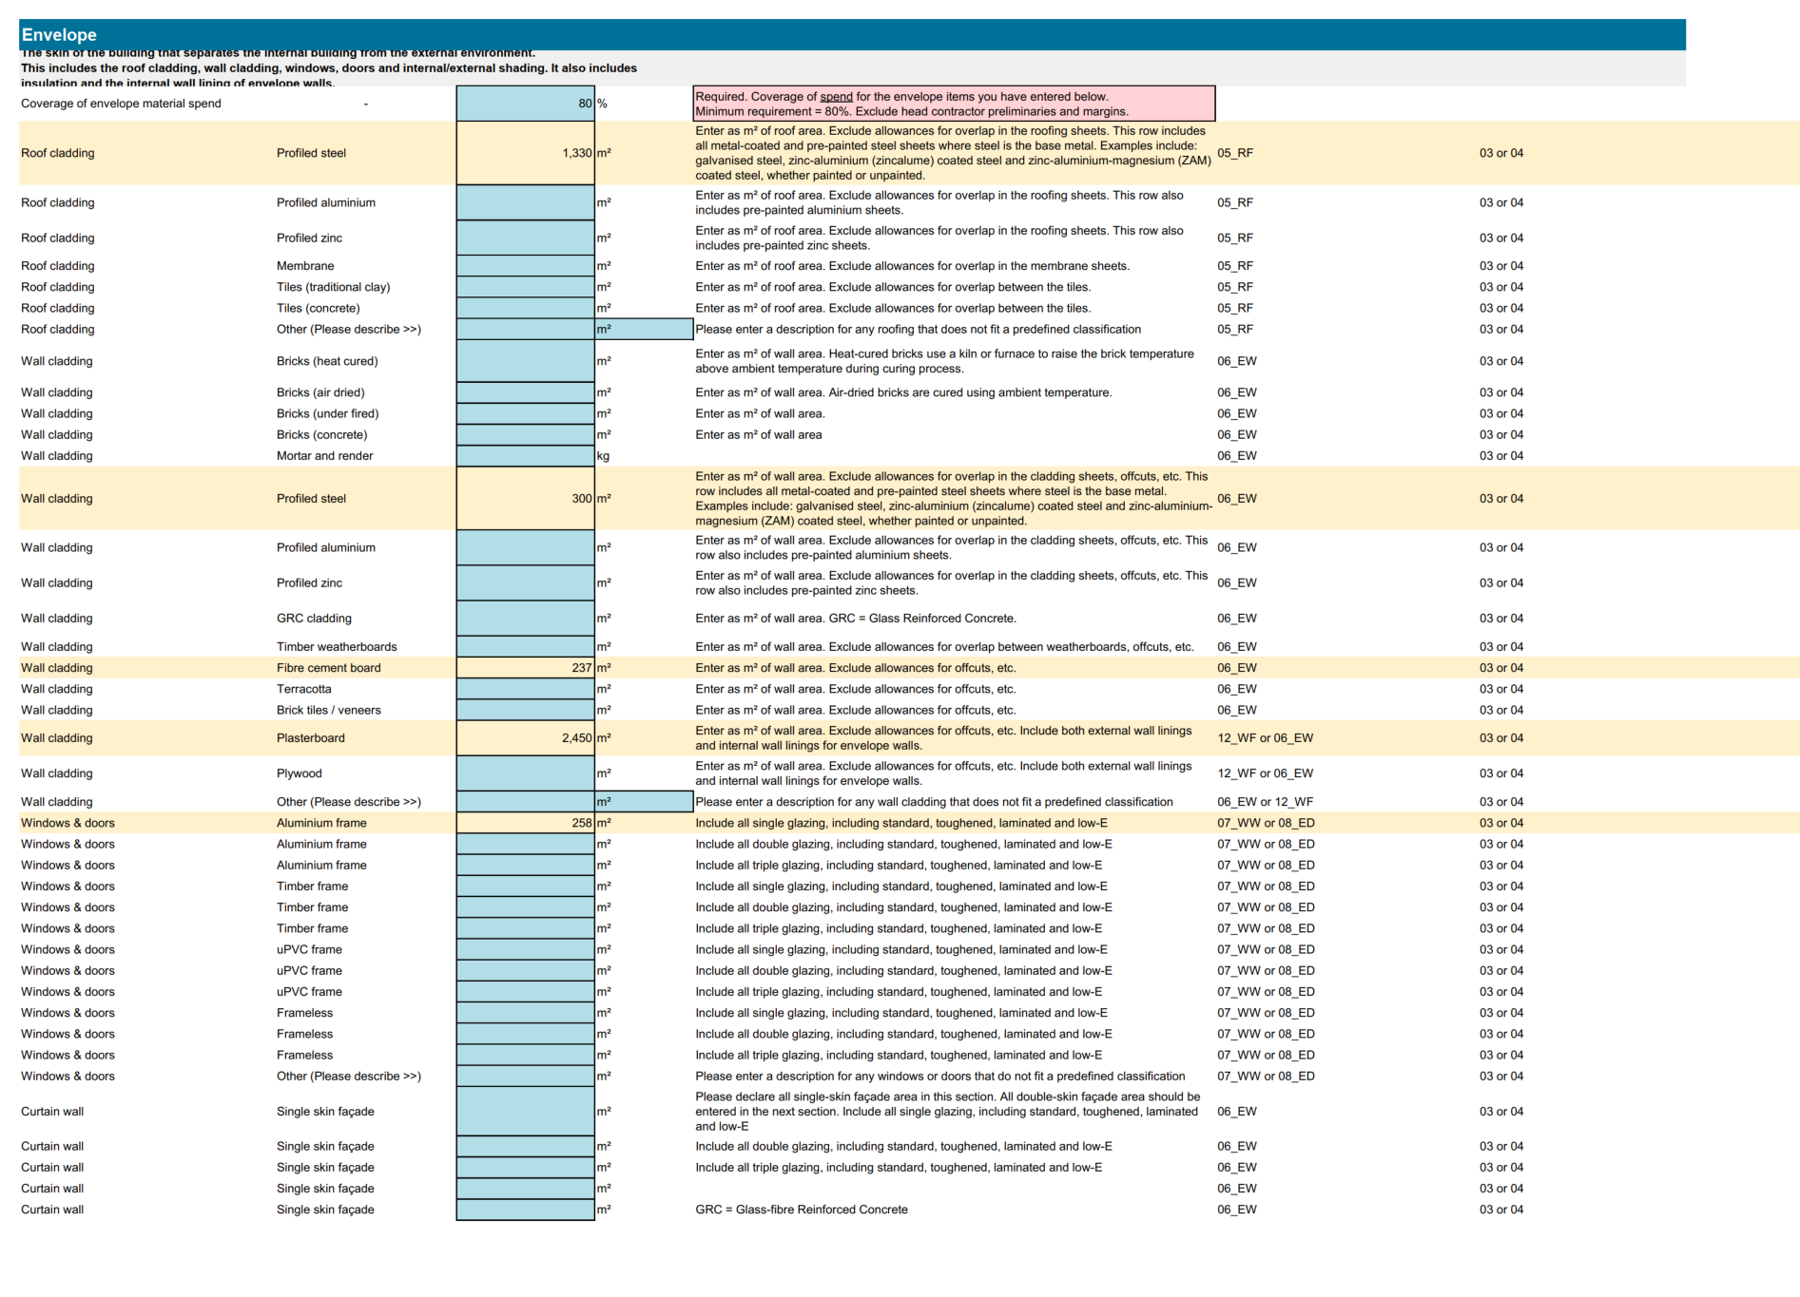
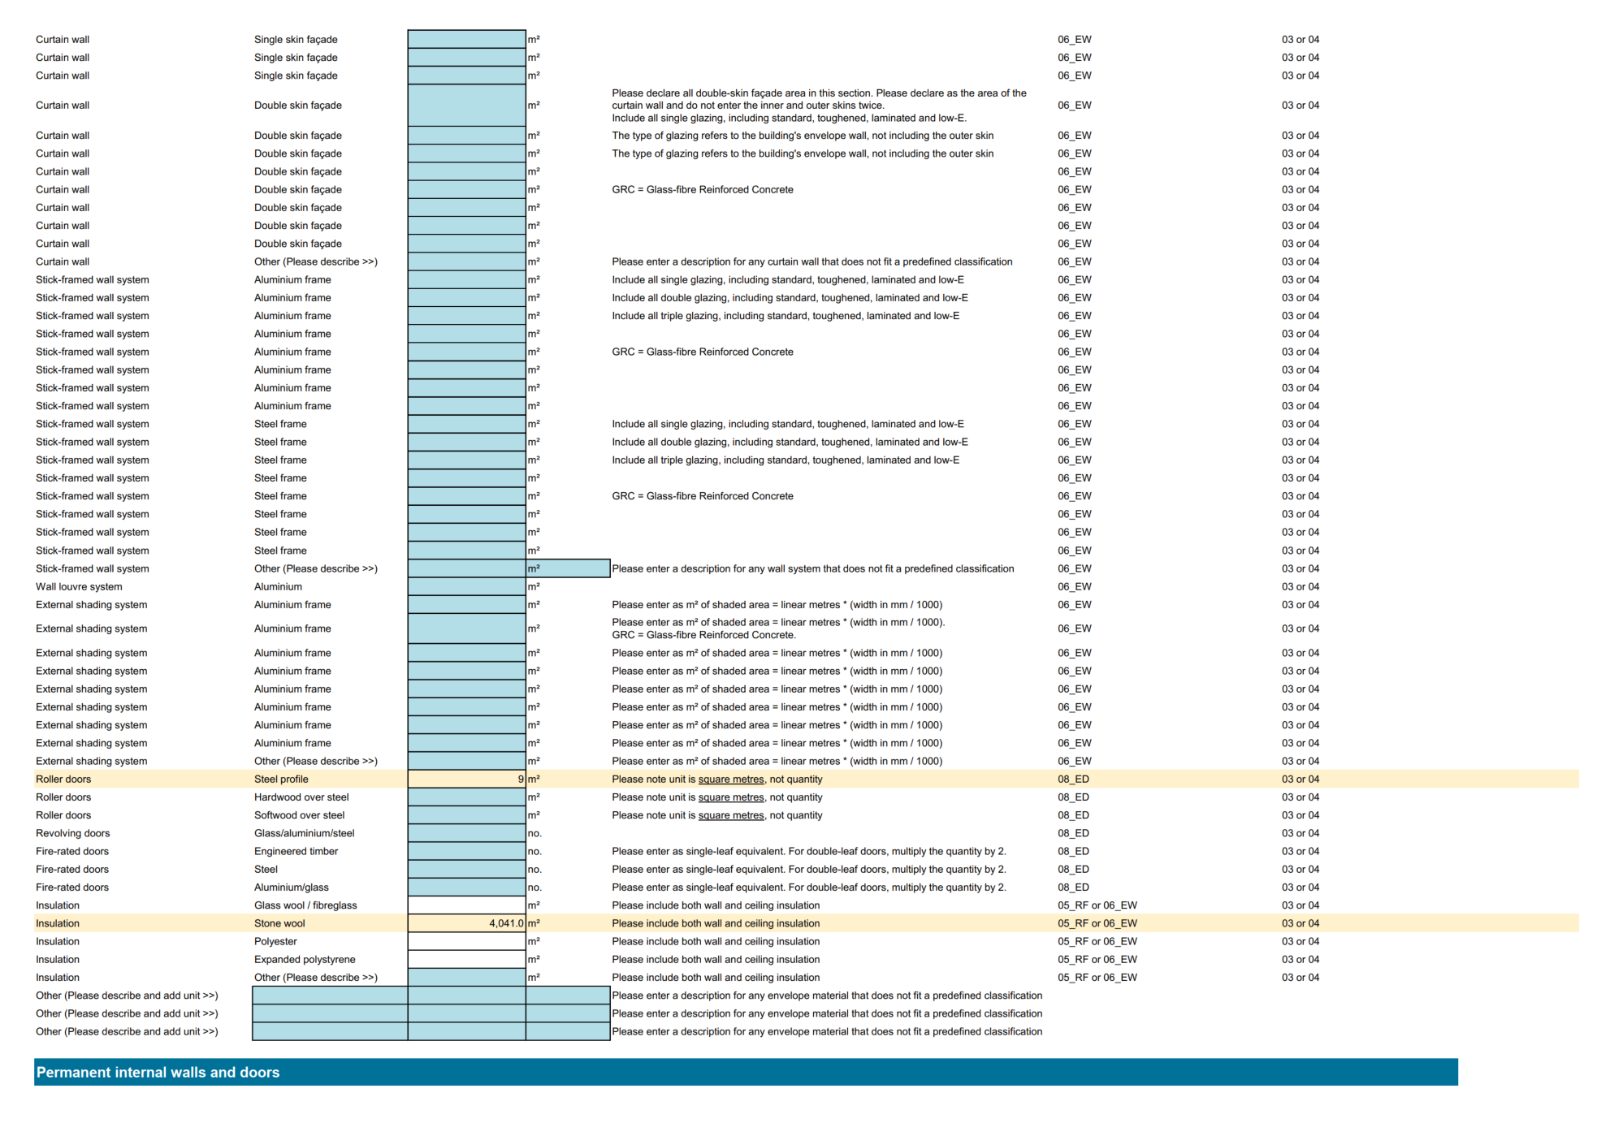
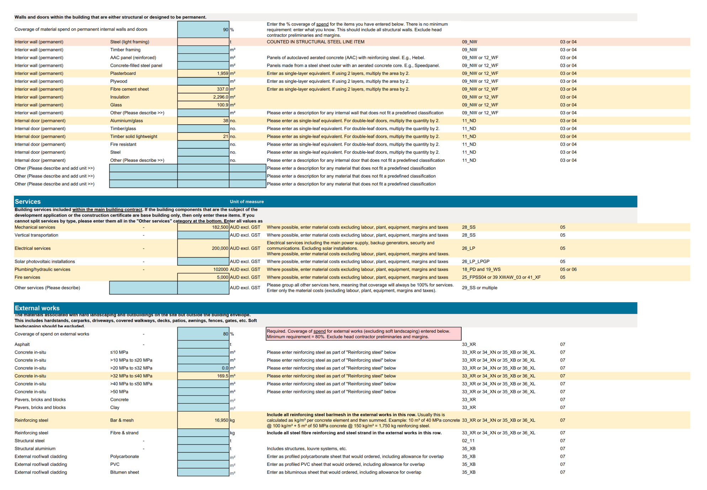

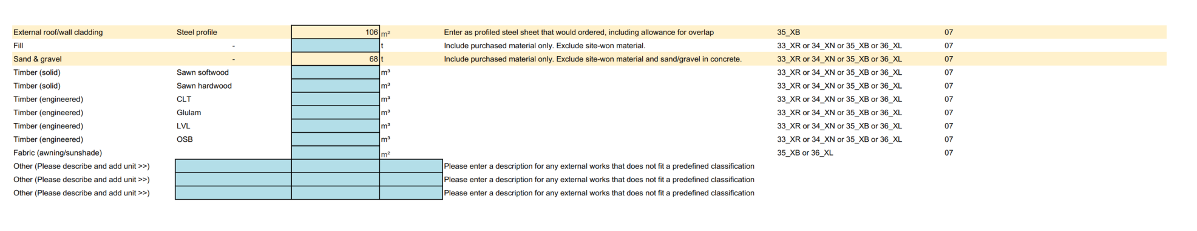
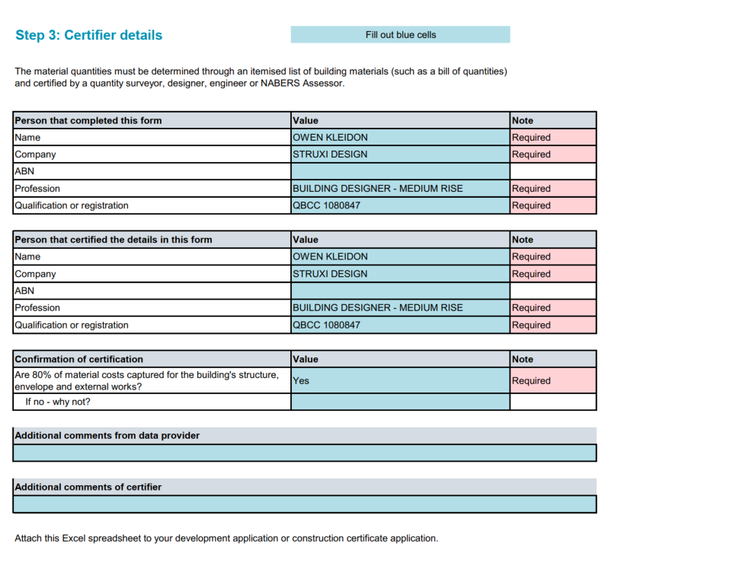

SEPP (Resilience and Hazards) 2021

Consideration has been given to Section 4.6 of the SEPP. Details of contamination and remedial measures affecting the previous Council site and adjoining commercial site are outlined below in this report. A separate assessment is provided for 39 Cunningham Street under the SEPP. A suitable condition (Draft Condition 7) recommended to address contamination issues.

Previous Council building and adjoining commercial building

It is noted that contamination has been addressed under the previous DA for demolition of the Council buildings and adjoining commercial building. It is considered that subject to suitable conditions (recommended) that the clauses 1(a) and (b) and (c) have been satisfied.

The use of the land is not changing, and accordingly clause 2 does not apply.

The provisions of clause (3) have been addressed in the demolition DA which has resulted in additional investigations and a Remedial Action Plan being prepared and submitted to the Council.

In terms of Clause (4), the land is not in an investigation area. Consideration has been given to Table 1. This was addressed in the DA for the demolition of the Council buildings and adjoining commercial development when the land use history identified a former car repair station on No. 35 Maitland Street. The land is not proposed to be used for residential, educational, recreational, or childcare purposes, or for the purposes of a hospital.

Details of Contamination

In short, the site has several types of contamination as might be expected from buildings of that age. As part of that DA, a report was commissioned from SMK Consultants in Moree, who reviewed the site undertaking a preliminary site investigation. This involved the following steps:

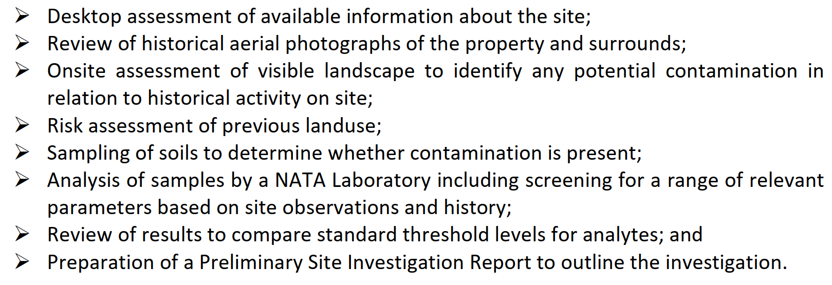

The report identified the following contaminants:

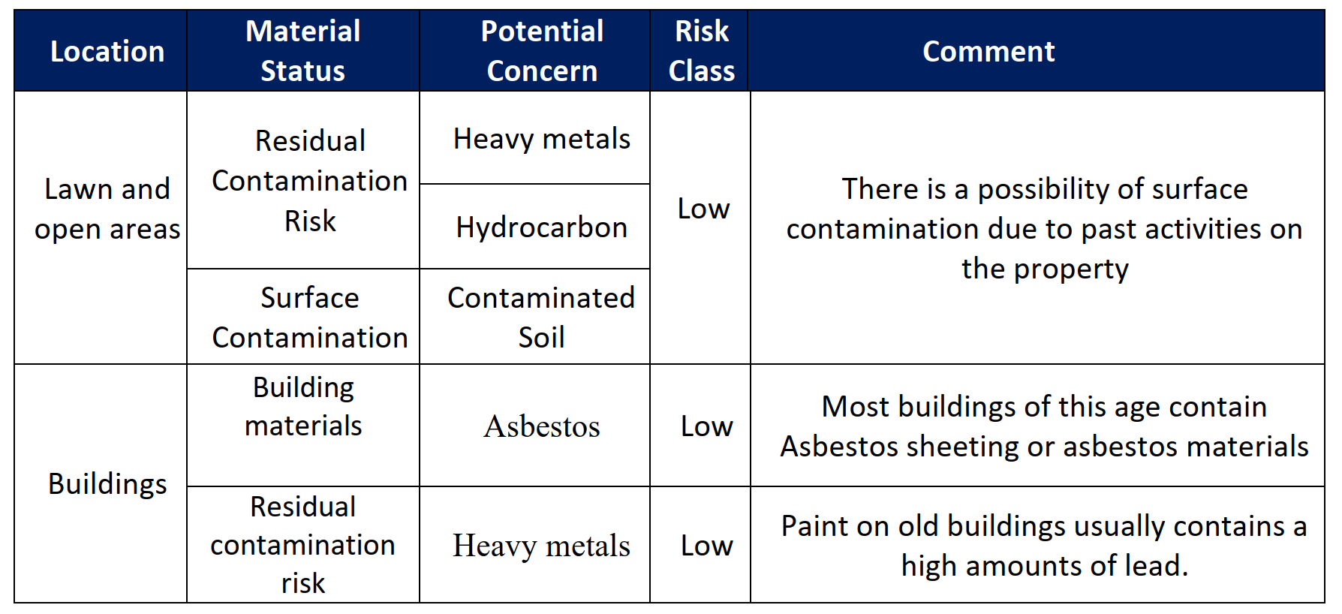

A sampling program was undertaken which focused on the areas with the highest likelihood of contamination. The following results were obtained.
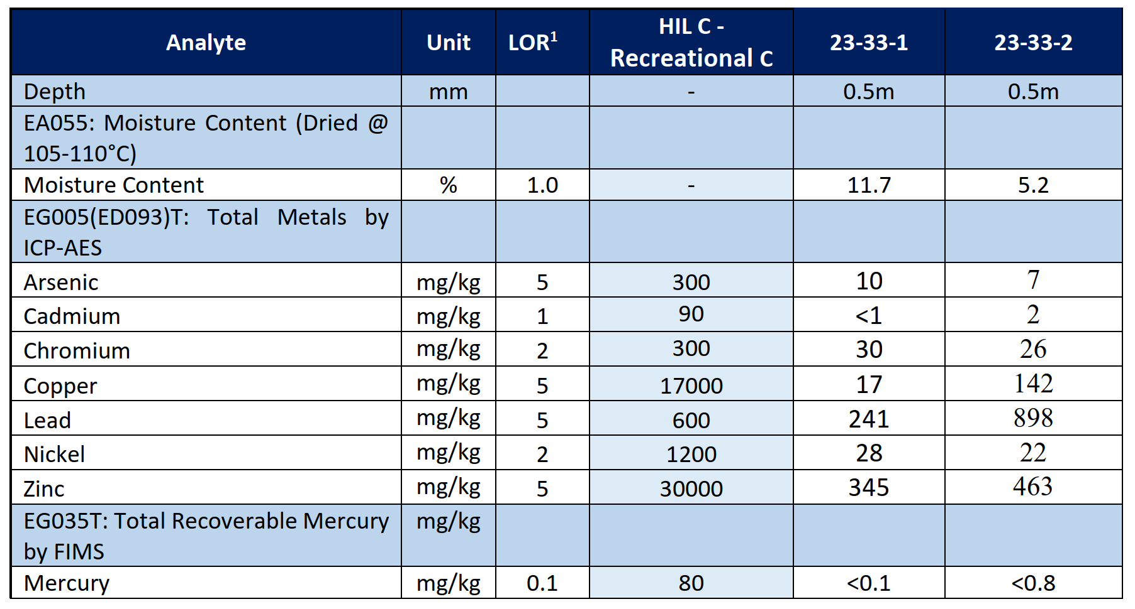
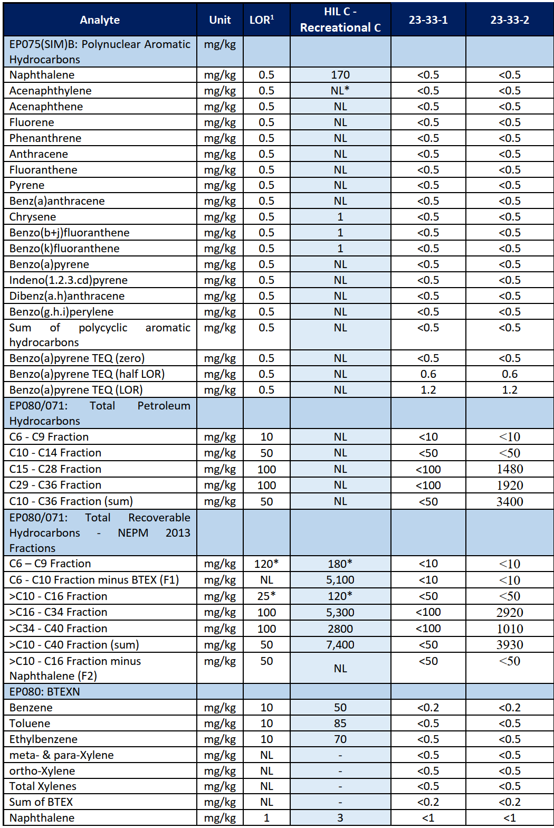

That report identified a staged remediation process.

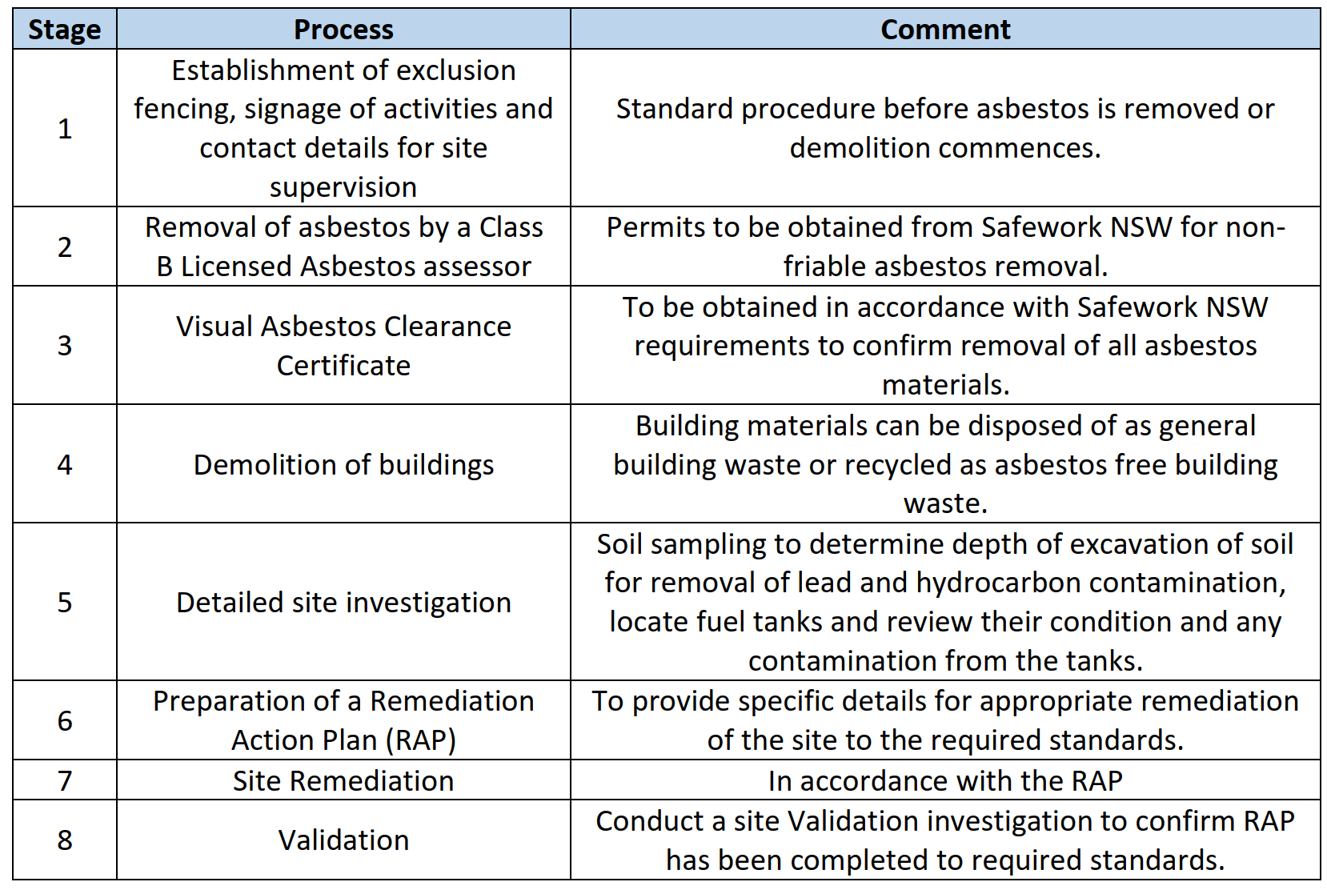

As can be seen from the table, ongoing investigations were recommended during the process as the demolition itself was likely to expose further contamination. This has, in fact, been the case and works are continuing to remediate the site in accordance with EPA protocols. Once the site has been adequately remediated for the proposed use, a site clearance certificate would issue from the monitoring consultants confirming that the site is clear for development.

Previous Residential Building at 39 Cunningham Street

It is noted that the land is proposed to be used for carparking. The change in use is such that the proposed land use is less sensitive than the current land use.

Under Clause (1) The age of the dwelling suggests that contamination may be present in terms of asbestos and lead-based paint. No other contamination is likely on the site. Standard precautions would be required for the demolition of this dwelling.

Under Clause (2) No use of the land for a purpose set out in Table 1 to the Guidelines is known to have occurred and therefore Clause (3) does not apply.

The land concerned does not meet any of the criteria in Clause (4).

Management of contamination is best achieved through a draft condition (Condition 7) which addresses management of this issue.

Gwydir Local Environmental Plan 2013

The relevant local environmental plan applying to the site is the Gwydir Local Environmental Plan 2013 (‘the LEP’). The site is located within the RU5 Zone pursuant to Clause 2.2 of the LEP.

The use is a permissible use under Gwydir LEP 2013, in that it is included under “Any other development not specified in item 2 or 4”. This use is considered in accordance with the zone objectives in that it provides services and facilities appropriate to a rural village.

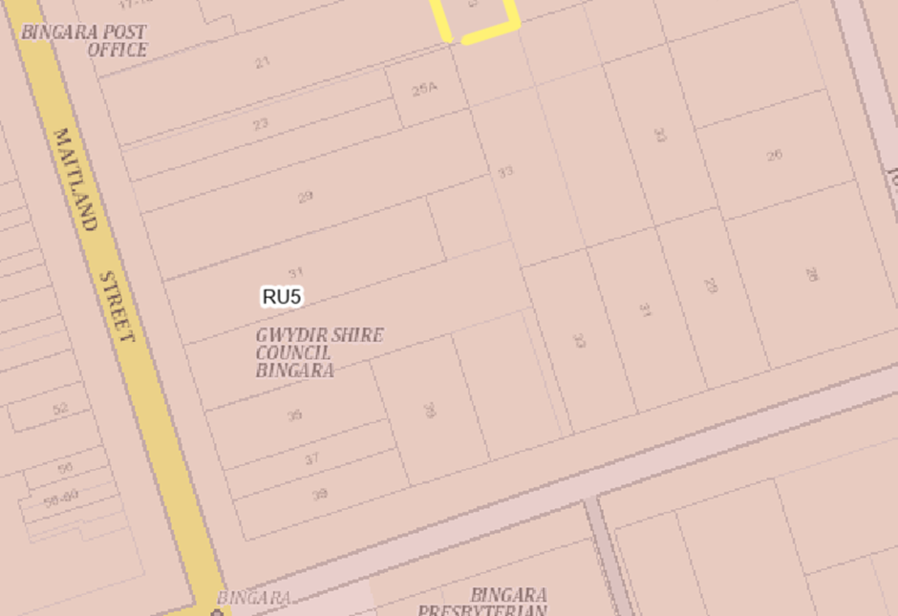
Figure: Zoning of the land

General Controls and Development Standards (Part 2, 4, 5 and 6)

Clause 6.4 addresses essential services. In considering Clause 6.4(e) it is noted that the land is existing serviced land in the Bingara Town Centre. Accordingly, the following services are already available and connected to the land: water supply, sewer and power. These are the subject of draft conditions 6 and 28.

Stormwater drainage was also available to the previous development, and details of the use of existing systems together with any new works would be detailed in the Construction Certificate.

Access has been the subject of discussion elsewhere in the report.

The proposal is considered to be generally consistent with the LEP.

- Section 4.15 (1)(a)(ii) - Provisions of any Proposed Instruments

There are no proposed instruments.
- Section 4.15(1)(a)(iii) - Provisions of any Development Control Plan

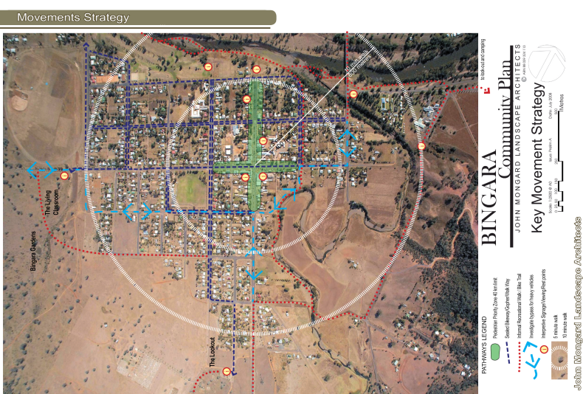
Gwydir Shire does not have a DCP. Instead, there are town plans for Warialda and Bingara. Set out below are some key aspects from the Bingara Town Plan which are of relevance to the site.
.
Figure: Bingara Community Plan Strategy

The Community Plan Strategy reinforces the key role of Maitland Street in the town, as the key “axis”.
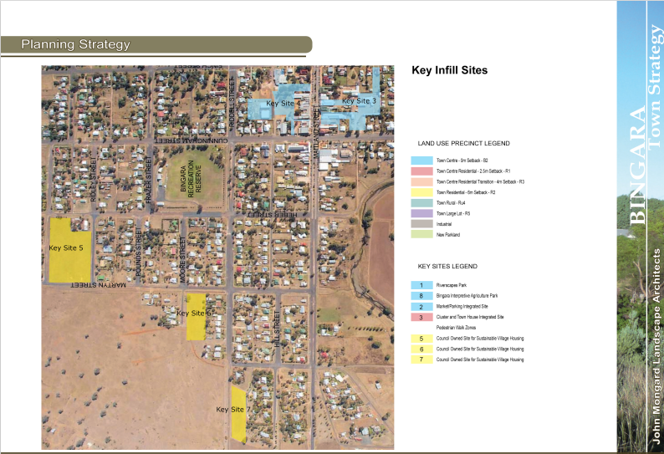

Figure: Bingara Key Infill Sites

The site is known as “Key site 3” and shown in light blue in the diagram.

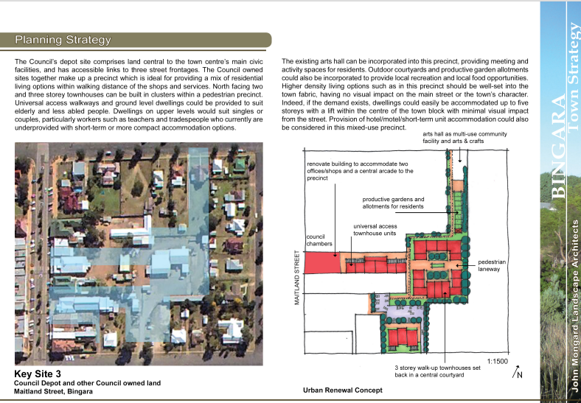
Figure: Bingara Town Strategy

The town strategy includes site of No. 33 as a “key site” in the town. The overall Council owned site is identified as forming a key precinct, with potential for a variety of uses, including town centre residential.

Figure: Bingara Key Infill Sites

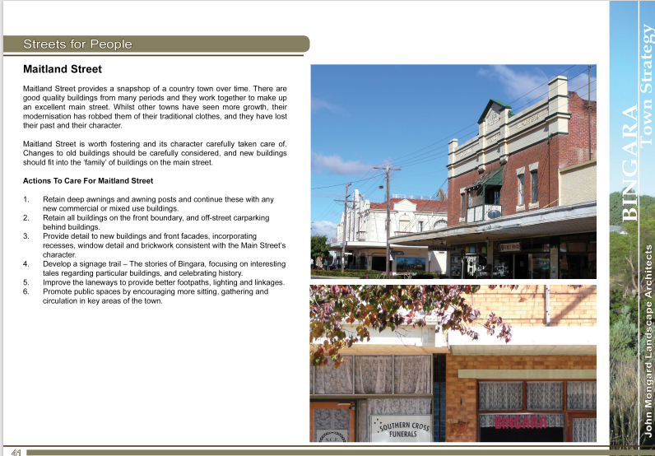
Figure: Actions to care for Maitland Street

The Bingara Town Strategy Plan identifies the Depot site as a key site (Site 3). The redevelopment of the Council chambers part of the site would not preclude future redevelopment of the depot site for housing, as per the plan, and recommendations in the Housing Strategy that is currently on exhibition.
In addition, consideration has been given to Actions to Care for Maitland Street. The key actions are listed below, together with comments:

- Retain deep awnings and awning posts and continue these with any new commercial or mixed use buildings.
The Memorial Hall did not have awnings, although the commercial building adjacent had a suspended awning. The replacement building is not a commercial building, but a community building. It is important, therefore, that the overall site “reads” in a way that reflects the former Council buildings on the site. In this instance, a variation regarding the provision of awnings is considered appropriate.

- Retain all buildings on the front boundary, and off-street carparking behind buildings.
Off street carparking is being increased, behind the building. For historical reasons, creating a zero setback for the whole site was not supported. The key community issue was retention of the façade of the old memorial hall, which is set back, and ensuring that the redeveloped site responded to that history.

- Provide detail to new buildings and front facades, incorporating recesses, window detail and brickwork consistent with the Main Street’s character.
The new building cluster preserves the existing façade of the memorial hall, though specifically conditioning painting treatment to echo an historical palette would be of advantage (draft Condition 8). The newer section avoids “pretend heritage” but is unashamedly modern. It does, however, have good attention to detailing on the recessed sections. The length addressing the street frontage makes a bold statement, but one which is consistent with monumental architecture associated with memorials. Overall, the height and the complexity are consistent with streetscape character, while the setbacks maintain links to the past buildings on the site.

- Develop a signage trail – The stories of Bingara, focusing on interesting tales regarding particular buildings, and celebrating history.
It was required, as part of the demolition requirements of the previous Council buildings, that an interpretive feature be included in the public courtyard. This would be consistent with this action.

- Improve the laneways to provide better footpaths, lighting and linkages.
No laneways are affected by the proposal.

- Promote public spaces by encouraging more sitting, gathering and (sic)
The site provides enhanced public opportunities by creating an attractive public space on the north of the new building. Details of street furniture to encourage seating and mingling would be included in the detailed landscaping plan. A suitable condition is proposed (draft Condition 2).

- S7.11 Development Contributions Plan

No Contributions Plan is relevant to the development.

- Section 4.15(1)(a)(iiia) – Planning agreements under Section 7.4 of the EP&A Act

There have been no planning agreements entered into and there are no draft planning agreements being proposed for the site.

- Section 4.15(1)(a)(iv) - Provisions of Regulations

Section 61 of the 2021 EP&A Regulation contains matters that must be taken into consideration by a consent authority in determining a development application, with the following matters being relevant to the proposal:
If demolition of a building proposed - provisions of AS 2601;
A draft condition is recommended (Condition
Section 62 (consideration of fire safety) and Section 64 (consent authority may require upgrade of buildings) of the 2021 EP&A Regulation are not relevant to the proposal.

Section 66A of the Environmental Planning and Assessment Regulation 2021

This section of the Regulation does not apply, as Council is not determining the application. Council does not have a formal policy regarding conflict of interest. In practice in this case conflict of interest issues have been addressed by the application being prepared by a third party, and the assessment being undertaken by a different third party.

The provisions of the 2021 EP&A Regulation have been considered and are addressed.

  - Section 4.15(1)(b) - Likely Impacts of Development

The likely impacts of that development, including environmental impacts on both the natural and built environments, and social and economic impacts in the locality must be considered. In this regard, potential impacts related to the proposal have been considered in response to the planning controls outlined above and the Key Issues section below.

Use of the Site
The development consists of a “like for like” development when compared with the previous uses of the site. Accordingly it is not anticipated that the uses would increase noise and traffic to any significant level when compared to the previous site uses.

Noise
Noise would be managed during construction according to EPA Guidelines. Operational noise (e.g. of plant and equipment) has been conditioned (draft Condition 33) to minimise impacts at nearby residential premises. Extracts from the Acoustic Report are provided over:
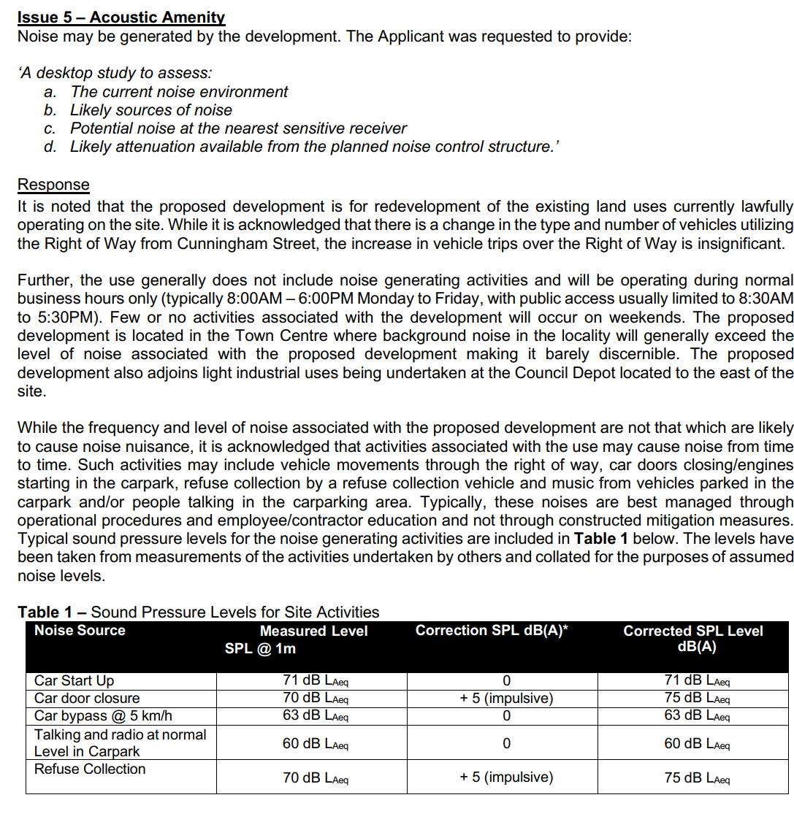

Visual Impact
A partial retention of the façade of the previous building, which was a war memorial hall, ensures that there is continuity in the streetscape, noting that a modern building is being erected on the lot adjoining the former hall. In general, the building “reads” in a way that is consistent with the streetscape.

Specific attention needs to be given to colours, with a suitable condition (Draft Condition 8) recommended.

Usability of Proposed Public Area
The public area should include seating, tables and the like to encourage people to gather and utilise the space. A suitable condition (Draft Condition 2) is recommended.

Parking
Consideration has been given to the quantum of parking. It is noted that the overall area of built form is reducing from 1461m² to 1098m². This is a reduction in area of some 25%. In addition, the former community hall has been demolished, and there is no longer the need to provide for larger events. Depot parking would be accommodated within the main depot site and the existing informal parking on Lot B, adjoining to the north. None of the depot parking is required to serve the development.

The previous site had parking at the rear for four cars only. The proposed office parking area was then informal and was typically utilised by some 16 vehicles per day. The new development provides a dedicated carpark area on Lot A, 39 Cunningham Street, the site of a former dwelling. This carpark area provides for 26 spaces. In addition, formalisation of the angle parking in Maitland Street is proposed, which would improve parking efficiency by an estimated 2 spaces.

In the absence of a DCP, guidance as to the adequacy of the proposed parking can come from typical parking rates for different types of development.
- Office space – Typically 1 space per 40m2

Looking to these guidelines, we find:
- 766m2 office space equates to 19 spaces

The community spaces would operate as follows. Council meetings are outside business hours, and ample parking is available on-street with angle parking provided. Toilet usage and counter attendance would generally be by persons already visiting the town centre who would generally park in the main street.

Field observation shows that there is no shortage of on-street parking in the vicinity. The tourist information centre would attract visitors to the town, however they, also, would predominantly utilise on-street parking.

The ten spaces available in the reconfigured parking together with the additional two spaces in Maitland Street are considered adequate to support the community uses.

The space would be compliant with AS2890. A condition (Draft Condition 10).

It should also be noted that formalisation of the existing depot parking (not the subject of this development application) provides an for twenty-two (22) spaces, which is in excess of the depot needs. Therefore, this area can act as over-flow parking if needed.

Access
Access was originally proposed via a Right of Way, and also through the Council’s depot site and informal parking area. In order to reduce the conflict between heavy vehicles accessing the depot and parking for the new Council building, the decision was taken to acquire 39 Cunningham Street, a house that would have been surrounded on three sides by the development. This is to be demolished under this application with the site to be available for dedicated parking and access.

A two-way access is proposed from Cunningham Street, that would cater for car traffic, together with access for a waste collection vehicle (which would be out of hours) and the occasional delivery vehicle (maximum size medium rigid; frequency 1-2 per business day).

The delivery vehicles would manoeuvre on site as shown on the swept area diagram. Pedestrian pathways have been identified that would minimise conflict with on-site vehicles.

CPTED
The issue of CPTED was given careful consideration in the design development. Essentially the tension was between demolishing much of the existing façade to improve surveillance into the site or retaining an element of considerable importance to the Bingara community. The on-balance decision was taken to keep the main façade elements, but to ensure as much transparency as possible.

Bingara is perceived by its residents as a safe town, as outlined in the Bingara Plan. This is borne out by statistics from the Bureau of Crime Statistics and Research which show that Gwydir Shire is generally low in crime except for domestic violence and stealing/robbery from dwellings and motor vehicles where it is low-mid range.

As part of security approached, the pathway from the community open space towards the rear of the site would be locked at night. A condition (draft Condition 39) is recommended.

Summary
It is considered that the proposal, subject to suitable conditions, will not result in any significant adverse impacts in the locality as outlined above.

  - Section 4.15(1)(c) - Suitability of the site

The site is suited for the development, noting that it was previously used for a similar purpose. It is well provided with services, is free from natural hazards and is compatible with adjoining and adjacent developments.

  - Section 4.15(1)(d) - Public Submissions

These submissions are considered in Section 4.3 of this report.

  - Section 4.15(1)(e) - Public interest

The development is considered to be in the public interest. Acoustic impacts are able to be mitigated though conditions of consent, and the proposal is consistent with planning controls, including the relevant SEPPs, the Regional Plan, the LEP and the Bingara Town Plan.

It will enable additional staff to be located in Bingara, and will contribute to community well-being. Consideration has been given to public safety in the design of the facility.

- REFERRALS AND SUBMISSIONS

  - Agency Referrals and Concurrence

The development application has no requirements to be referred to agencies, and no concurrence requirements apply.
  - Council Officer Referrals

The development application has been referred to various Council officers for technical review as outlined Table 4.

Table 4: Consideration of Council Referrals
Officer | Comments | Resolved
Engineering | Council’s Engineering Officer reviewed the submitted stormwater concept plan and considered that there were no objections subject to conditions. No comment was made on access or parking issues. | Y
Building and Environment | The imposition of conditions relating to a waste management plan was recommended. | Y

The issues raised by Council officers are addressed in conditions.

  - Community Consultation

The proposal was notified in accordance with the Council’s Community Participation Plan from 11 March 2024 until 10 April 2024The notification included the following:

- An advertisement in the local newspaper – Northern Daily Leader
- A sign placed on the site;
- Notification on Council’s website and Facebook page;
- Notification letters sent to adjoining and adjacent properties (17 letters sent);
- Notification at Council venues being the Bingara Admin Centre, Bingara Library, Warialda Admin Centre, Warialda Tourist Information Centre.

The Council received a total of one unique submission, comprising 1 objection. The issues raised in these submissions are considered in Table 5. A submitter list is attached.

Table 5: Community Submissions
Issue | No of submissions | Council Comments
Use of Right of Way  Owner of the right of way expressed concern about lack of consultation and indicated future intensions to use the land. | 1 | The development has been reconfigured to avoid the need to utilise the right of way, although this would have facilitated service vehicle access.

It was not considered necessary to fully re-notify the plans given there was only one objection. Instead, a limited supplementary notification of seven (7) days was carried out of the two properties, the subject of the right of way, as well as the commercial use opposite the proposed carpark. No submissions were received.

- SUMMARY OF KEY ISSUES
The following key issues are relevant to the assessment of this application having considered the relevant planning controls and the proposal in detail:
  - Contamination
This was considered as part of the demolition of the previous buildings, and site remediation has been occurring as part of the demolition process. A site contamination clearance certificate is being sought once clean-up is completed. Demolition of the dwelling at 63 Cunningham Street has been assessed. A condition is recommended to address contamination issues prior to issue of a construction certificate (Draft Condition 7).
  - Acoustics
The response to the RFI for the development provided a desk-top study which identified that the likely acoustic impacts of the proposal would be within the 5dbA criterion at the nearest sensitive receiver. It is noted that this dwelling has now been purchased by Council and demolished.
  - Traffic and Access
The majority of traffic would enter and leave the formalised parking area proposed on 39 Cunningham Street. Access now does not utilise the existing rights of way.
5.4 Parking
A revised approach to parking has been applied through the purchase of the adjoining dwelling and optimisation of on-street parking.
  - Urban Design

The proposed building form presents sympathetically to the streetscape and is similar bulk and scale to existing development. Colours need careful consideration.

It is considered that it positively contributes to the character of the area.

- CONCLUSION

This development application has been considered in accordance with the requirements of the EP&A Act and the Regulations as outlined in this report. Following a thorough assessment of the relevant planning controls, issues raised in submissions and the key issues identified in this report, it is considered that the application can be supported.

- RECOMMENDATION

That the Development Application DA No 48/2023 for a community facility and office development at 33-35 Maitland Street Bingara be APPROVED pursuant to Section 4.16(1)(a) or (b) of the Environmental Planning and Assessment Act 1979 subject to the draft conditions of consent attached to this report at Attachment A.

The following attachments are provided:

- Attachment A – Revised Draft Conditions of Consent
- Attachment B – Amended SEE – 03 July 2024.
- Attachment C – Plan Set for DA Approval. Contains the complete architectural plan set and landscaping plans.

